The Jelly Bean
Flavor Test

Curriculum Overview
Students will be introduced to neurosensory topics centered on the integration of the five senses. In addition, students will be encouraged to make predictions, and to visualize data through graphing. This lesson is targeted for students in grades 3-8.

Materials
Flavored jellybeans, pre-sorted (Jelly Belly Brand)
Ziploc bags (quart) or other container
Paper or poster board for graphing
Markers or stickers for data collection
Brain model or schematic
Food picture sheet
Poker chips

Lesson Introduction to Students
Do you like to eat?
What’s your favorite food?
Think of the flavor of your favorite food: How do you know what its flavor is?
Which sense is most important for recognizing food flavor?
The five senses are? Taste, Smell, Sight, Hearing, Touch

Neuroscience Concepts:
Each Sense is recognized by a specialized part of the body, and information is sent to different parts of the brain. The brain combines the information to recognize and remember a food’s flavor.

Optional Activity: Use a brain model or schematic to show the parts of the brain that is utilized for each sense, and where information is integrated. Students can then point to the parts of their body that corresponds to the sense and then to the part of their head where the sense is represented in the brain. If there’s enough time, students can color the sense areas on to a brain map.

Jelly Bean Tests
Each Group gets a food sheet, poker chips, stickers, markers, graphing paper, and three or more bags of jelly beans.
Sense of sight:
- “By looking at these jelly beans, predict the flavor and put your chip on the food that you think represents its flavor.”
- Eat the jelly bean. “Was your prediction correct? “
Facilitator:
- Draw a graph
- Title the Graph
- Compsare X- axis = yes/no (Independent Variable, what we choose to test/ measure, the “Cause”)
- Each student places a sticker in the column that matches the accuracy of their prediction. (Yes vs. No)
Repeat for Taste (while holding nose) and Smell (eyes closed).
Do touch and hearing as time permits.

Wrap Up
What sense was most important for recognizing the flavor? Could any sense work alone while reliably recognizing the flavor? How many brain areas are involved in identifying food?

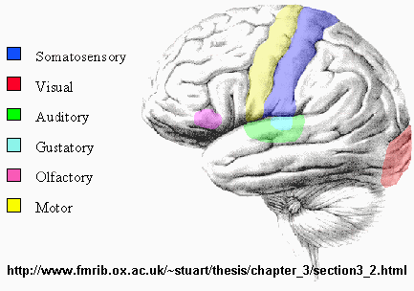
Go further
What part of the body is used to detect each sense? Each sense sends information about experiences to a specific part of the brain. Have students color the brain map for the sensory areas. Signals from each sensory brain area are combined in order to remember how a food tastes, looks and whether or not we like it!
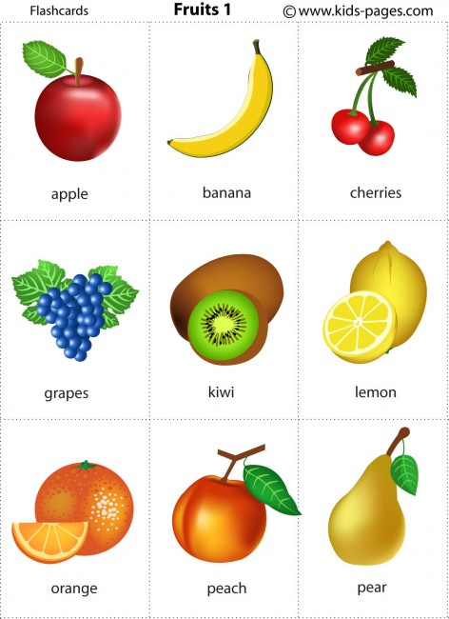

Example Graphs

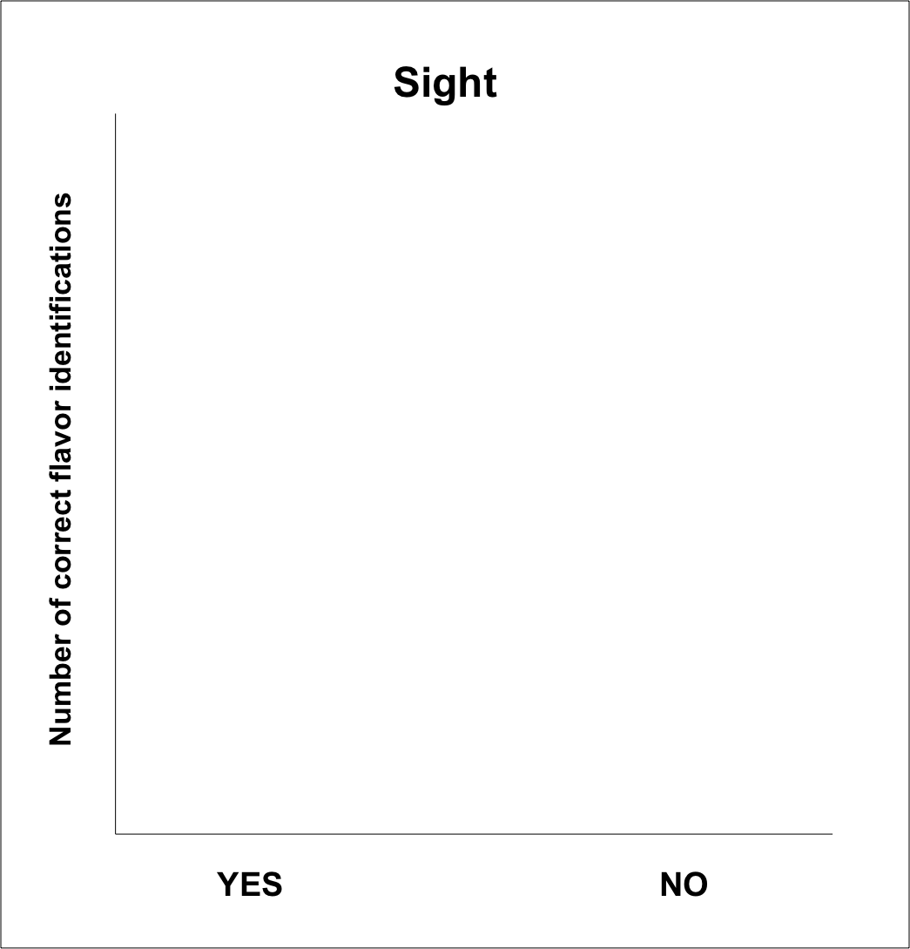

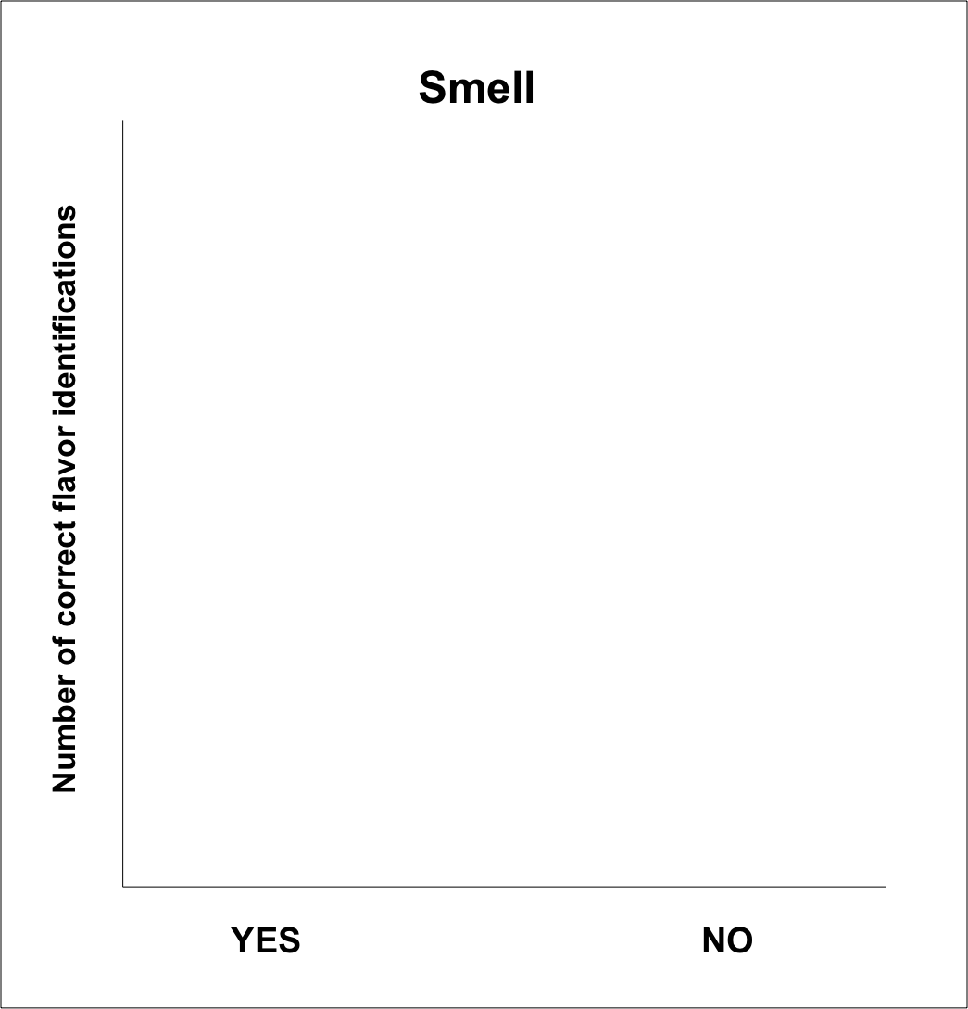

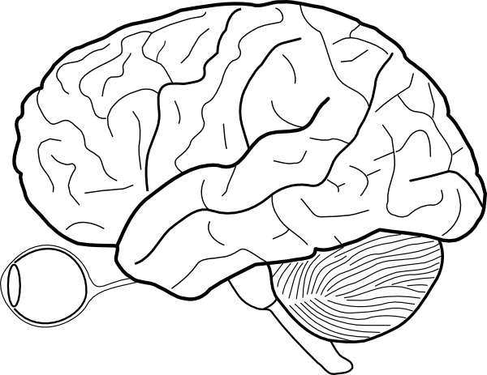

http://www.clker.com

